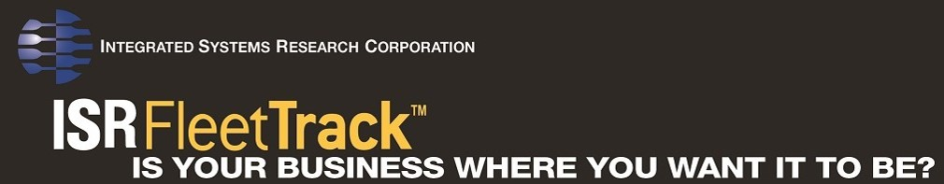
Hours of Service (HOS)
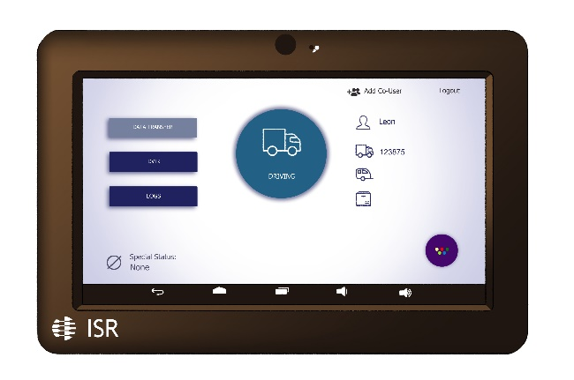
Seamless, full functionality integrated into ISRFleetTrackTM
Complies with 49 CFR Part 395 D.O.T. regulations

Feature Highlights include:
- Roadside Inspection Friendly
- NO Additional Data Service Required!
- Log-in & log-out for up to 2 Drivers per tablet
- Alerts if not logged-in & vehicle is moving
- Up to 3 Trailers per tablet
- Status Alerts: Yard Moves, Personal Use - Driver’s Approval Reminder Alert
- Customizable Status Alerts
- Log certifications

